1. Goal:

Credit One is a credit scoring service. The Credit One stakeholders would like to find out how to minimize the customer default rate. This is being done so that partners who issue credit based on Credit One’s score do not suffer losses due to customers defaulting on loans issued to customers based on Credit One’s credit scoring application.

1. Framework: *Zumel and Mount, Practical Data Science with R*
2. The data is available in a database deployed in AWS. The data contains Customer ID, Age, Credit balance, their monthly payments, monthly billing and whether they are a customer in good standing or not.
3. The data will be utilized within the Jupyter Notebook. Data might be exported to Excel for further analysis. It will not be shared or deployed to an unsecure cloud application.
4. Duplicate entries have been determined in the data. These entries will be cleansed before analysis is performed.
5. 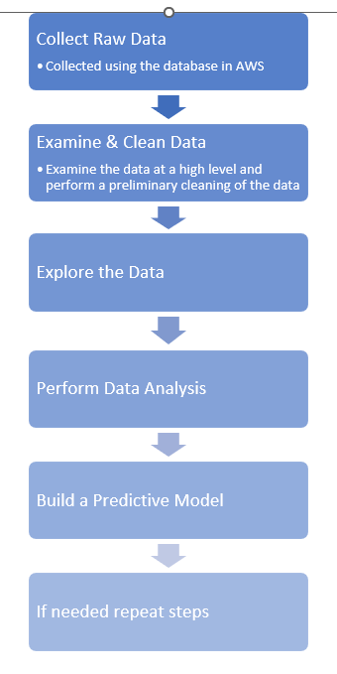

1. It is unclear whether the 1st column is credit limit or credit balance. There is no column for 2nd payment. The bill amounts seem to be disproportionately large in comparison to the payments in many cases.

**Why?**

Credit One is a credit scoring service. The Credit One stakeholders would like to find out how to minimize the customer default rate. This is being done so that partners who issue credit based on Credit One’s score do not suffer losses due to customers defaulting on loans issued to customers based on Credit One’s credit scoring application.

**What problem are we trying to solve?**

The stakeholders would like the solution to help determine –

* How much credit should be issued to customers so as to minimize uncollected debt
* Improve the credit default rate.

**Why is the current situation inadequate?**

Credit One’s partners are issuing credit to their customers based on Credit One’s credit scoring algorithm. Credit One’s partners, however, have seen an increase in customer defaults. This situation needs to be rectified as soon as possible.

**Resources:**

We would need:

* We would need Data
* A tool to analyze information
* Access to key Credit One business and technical resources.

**Deployment:**

The result of the project will be deployed as an algorithm which would provide recommendations on the creditworthiness of a customer.

**Data:**

The data is available in a database deployed in AWS. The data contains Customer ID, Age, Credit balance, their monthly payments, monthly billing and whether they are a customer in good standing or not.

The data quality is currently being evaluated.

**Model:**

We will use Python to build a model. Data samples will be extracted to train the model. The team will determine the accuracy of the model. If accuracy is high the model will be deployed for usage. We are planning to apply Regression and Classification models to solve this problem.